# **Recyclable And Low Fat Products**

## **Question:**

<https://leetcode.com/problems/recyclable-and-low-fat-products/>

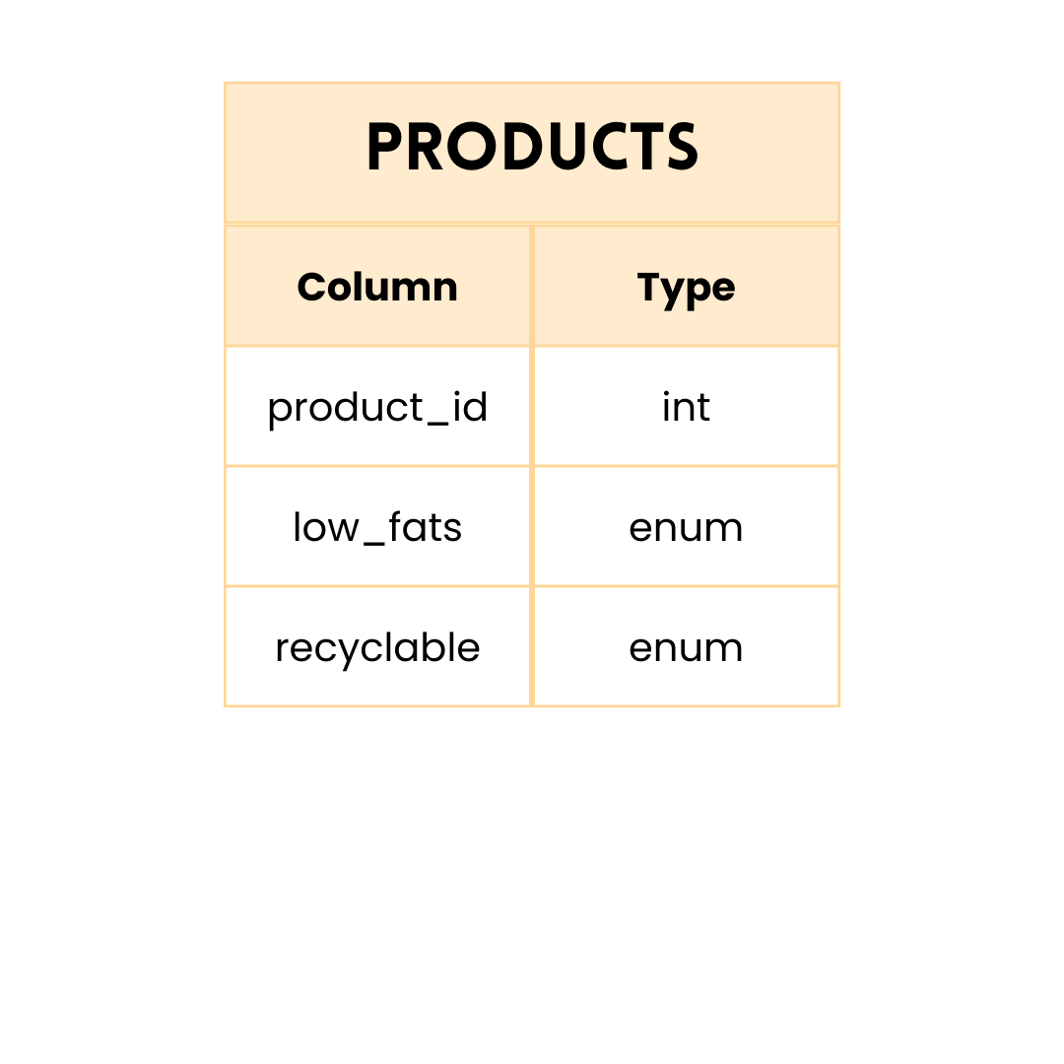

product_id is the primary key for this table.

low_fats is an ENUM of type ('Y', 'N') where 'Y' means this product is low fat and 'N' means it is not.

recyclable is an ENUM of types ('Y', 'N') where 'Y' means this product is recyclable and 'N' means it is not.

**Write an SQL query to find the ids of products that are both low fat and recyclable.**

**Return the result table in any order.**

## **Query 1**

Using a simple **WHERE** clause and **AND** operator.

SELECT

product_id

FROM Products

WHERE (low_fats = 'Y') AND (recyclable = 'Y')

## **Query 2**

Instead of using **AND**, I tried using **INTERSECT** to join the 2 conditions.

SELECT

product_id

FROM Products

WHERE (low_fats = 'Y' )

INTERSECT

SELECT

product_id

FROM Products

WHERE (recyclable = 'Y')

As we saw in Day 1 question, here Query 1 was faster and Query 2 only worked on MS SQL Server and not on MySQL.

**So Query 1 turned out to be the best in both the cases.**

**PS :** This question was asked in Facebook Data Engineering Interview : <https://leetcode.com/problems/recyclable-and-low-fat-products/discuss/1062936/SQL-1-liner-solution-(This-is-a-FB-DE-interview-question)>